|  |  |
| --- | --- |
| **Ex.No:1** | **MACHINE LEARNING TECHNIQUES FOR PREDICTIVE ANALYTICS** |
|  |

**AIM**:

To implement Predictive Analysis using R to diagnosis whether or not a person has heart disease based on past medical data.

**DATASET DESCRIPTION:**

The Cleveland data set of heart disease which is used to build a predictive model that classifies that the person will have heart disease based on certain feature variables. This database is a subset of 14variables. The "goal" field refers to the presence of heart disease in the patient. It is integer valued from 0 (no presence) to 4. Experiments with the database have concentrated on simply attempting to distinguish presence (values 1,2,3,4) from absence (value 0).

**ALGORITHM:**

Step 1: Import Dataset.

Step 2: Display the structure of the data set.

Step 3: Label the data set.

Step 4: Remove redundant variables from dataset (Data Preparation).

Step 5: Convert data to numeric format.

Step 6: Identify the rows with missing data.

Step 7: Display the structure of the data after removal of missing data.

Step 8: Transform classes for output.

Step 9: Build Model (Data Splicing).

Step 10: Do Classification by KNN (K Nearest Neighbor) Algorithm to make predictions

Step 11: Display Predictions.

**PROCEDURE:**

**STEP 1: IMPORT DATASET.**

**data <- read.csv("D://heart.csv")**

**STEP 2: DISPLAY THE STRUCTURE OF THE DATA SET.**

**str(data)**

'data.frame': 303 obs. of 15 variables:

$ sno : int 1 2 3 4 5 6 7 8 9 10 ...

$ age : int 63 37 41 56 57 57 56 44 52 57 ...

$ sex : int 1 1 0 1 0 1 0 1 1 1 ...

$ cp : int 3 2 1 1 0 0 1 1 2 2 ...

$ trestbps: int 145 130 130 120 120 140 140 120 172 150 ...

$ chol : int 233 250 204 236 354 192 294 263 199 168 ...

$ fbs : int 1 0 0 0 0 0 0 0 1 0 ...

$ restecg : int 0 1 0 1 1 1 0 1 1 1 ...

$ thalach : int 150 187 172 178 163 148 153 173 162 174 ...

$ exang : int 0 0 0 0 1 0 0 0 0 0 ...

$ oldpeak : num 2.3 3.5 1.4 0.8 0.6 0.4 1.3 0 0.5 1.6 ...

$ slope : int 0 0 2 2 2 1 1 2 2 2 ...

$ ca : int 0 0 0 0 0 0 0 0 0 0 ...

$ thal : int 1 2 2 2 2 1 2 3 3 2 ...

$ target : int 1 1 1 1 1 1 1 1 1 1 ...

**STEP 4: REMOVE REDUNDANT VARIABLES FROM DATASET (DATA PREPARATION).**

**> data$sno <- NULL**

**> str(data)**

'data.frame': 303 obs. of 14 variables:

$ age : int 63 37 41 56 57 57 56 44 52 57 ...

$ sex : int 1 1 0 1 0 1 0 1 1 1 ...

$ cp : int 3 2 1 1 0 0 1 1 2 2 ...

$ trestbps: int 145 130 130 120 120 140 140 120 172 150 ...

$ chol : int 233 250 204 236 354 192 294 263 199 168 ...

$ fbs : int 1 0 0 0 0 0 0 0 1 0 ...

$ restecg : int 0 1 0 1 1 1 0 1 1 1 ...

$ thalach : int 150 187 172 178 163 148 153 173 162 174 ...

$ exang : int 0 0 0 0 1 0 0 0 0 0 ...

$ oldpeak : num 2.3 3.5 1.4 0.8 0.6 0.4 1.3 0 0.5 1.6 ...

$ slope : int 0 0 2 2 2 1 1 2 2 2 ...

$ ca : int 0 0 0 0 0 0 0 0 0 0 ...

$ thal : int 1 2 2 2 2 1 2 3 3 2 ...

$ target : int 1 1 1 1 1 1 1 1 1 1 ...

**STEP 5: CONVERT DATA TO NUMERIC FORMAT.**

data$testno <- as.numeric(data$testno)

**STEP 6: IDENTIFY THE ROWS WITH MISSING DATA.**

**> data<-data[complete.cases(data),]**

**STEP 7: DISPLAY THE STRUCTURE OF THE DATA AFTER REMOVAL OF MISSING DATA.**

**> str(data)**

'data.frame': 303 obs. of 14 variables:

$ age : int 63 37 41 56 57 57 56 44 52 57 ...

$ sex : int 1 1 0 1 0 1 0 1 1 1 ...

$ cp : int 3 2 1 1 0 0 1 1 2 2 ...

$ trestbps: int 145 130 130 120 120 140 140 120 172 150 ...

$ chol : int 233 250 204 236 354 192 294 263 199 168 ...

$ fbs : int 1 0 0 0 0 0 0 0 1 0 ...

$ restecg : int 0 1 0 1 1 1 0 1 1 1 ...

$ thalach : int 150 187 172 178 163 148 153 173 162 174 ...

$ exang : int 0 0 0 0 1 0 0 0 0 0 ...

$ oldpeak : num 2.3 3.5 1.4 0.8 0.6 0.4 1.3 0 0.5 1.6 ...

$ slope : int 0 0 2 2 2 1 1 2 2 2 ...

$ ca : int 0 0 0 0 0 0 0 0 0 0 ...

$ thal : int 1 2 2 2 2 1 2 3 3 2 ...

$ target : int 1 1 1 1 1 1 1 1 1 1 ...

**STEP 8: TRANSFORM CLASSES FOR OUTPUT.**

**> data$target <- factor(ifelse(data$target == 1, "positive", "negative"))**

**> str(data)**

'data.frame': 303 obs. of 14 variables:

$ age : int 63 37 41 56 57 57 56 44 52 57 ...

$ sex : int 1 1 0 1 0 1 0 1 1 1 ...

$ cp : int 3 2 1 1 0 0 1 1 2 2 ...

$ trestbps: int 145 130 130 120 120 140 140 120 172 150 ...

$ chol : int 233 250 204 236 354 192 294 263 199 168 ...

$ fbs : int 1 0 0 0 0 0 0 0 1 0 ...

$ restecg : int 0 1 0 1 1 1 0 1 1 1 ...

$ thalach : int 150 187 172 178 163 148 153 173 162 174 ...

$ exang : int 0 0 0 0 1 0 0 0 0 0 ...

$ oldpeak : num 2.3 3.5 1.4 0.8 0.6 0.4 1.3 0 0.5 1.6 ...

$ slope : int 0 0 2 2 2 1 1 2 2 2 ...

$ ca : int 0 0 0 0 0 0 0 0 0 0 ...

$ thal : int 1 2 2 2 2 1 2 3 3 2 ...

$ target : Factor w/ 2 levels "negative","positive": 2 2 2 2 2 2 2 2 2 2 ...

**STEP 9: BUILD MODEL (DATA SPLICING).**

**> trainingSet <- data[1:200,1:13]**

**> testSet <- data[201:303,1:13]**

**> trainingOutcomes <- data[1:200,14]**

> **testOutcomes <- data[201:303,14]**

**> library(class)**

**STEP 10: DO CLASSIFICATION BY KNN (K NEAREST NEIGHBOR) ALGORITHM TO MAKE PREDICTIONS**

**> predictions <- knn(train = trainingSet, cl = trainingOutcomes, k= 14, test = testSet)**

**> predictions**

[1] positive positive negative positive positive positive positive positive

[9] positive positive positive positive positive positive positive positive

[17] positive positive positive positive positive positive positive positive

[25] positive positive positive positive positive positive positive positive

[33] positive positive positive positive positive positive positive positive

[41] positive positive positive negative positive positive positive positive

[49] positive positive positive positive positive positive positive positive

[57] positive positive positive positive positive positive positive positive

[65] positive positive positive positive positive positive positive positive

Levels: negative positive

**STEP 11: DISPLAY PREDICTIONS.**

**table(testOutcomes, predictions)**

predictions

testOutcomes negative positive

negative 3 100

positive 0 0

|  |  |
| --- | --- |
| AIM & DATASET DESCRIPTION | /25 |
| ALGORITHM | /20 |
| PROCEDURE | /45 |
| VIVA | /10 |
| TOTAL | /100 |

**RESULT:** Thus the Machine Learning Techniques for Predictive Analytics is implemented.

|  |  |
| --- | --- |
| **Ex.No:2** | **PREDICTION OF CREDIT RISK USING LINEAR REGRESSION** |
|  |

**AIM:**

To implement linear regression technique to predict the customer credit risk using credit card data set.

**DATASET DESCRIPTION:**

This dataset is part of "An Introduction to Statistical Learning with Applications in R" available at http://www-bcf.usc.edu/~gareth/ISL/index.html

**ASSUMPTIONS**

The following assumptions about the dataset have been made:

* Credit card Balance refers to the average monthly balance across all of the cards owned by a cardholder. This assumption was made as a result of the Cards variable which refers to the number of credit cards owned by a person and has only one associated Balance figure.
* The Balance is calculated as the highest amount incurred on a credit card in a given month. For example, if a cardholder spends $400, $500, and $600 over the course of three months, and each month pays the balance in full, the average balance will be recorded as $500 (i.e. any preliminary balances before the maximum are not taken into account, neither is the final balance of zero).

**ALGORITHM:**

Step 1: Import the Dataset.

Step 2: Define the categorical variables.

Step 3: Represent the data in Histograms

Step 4: Finding out the Outliers and remove data which is deviating.

Step 5: Examine Missing data from dataset

Step 6: Replacing the Missing data in the dataset

**PROCEDURE:**

**STEP 1: IMPORT THE DATASET.**

**credit <- read.csv('C:/Users/User/Desktop/credit.csv')**

**str(loan_data)**

'data.frame': 29092 obs. of 8 variables:

$ loan_status : int 0 0 0 0 0 0 1 0 1 0 ...

$ loan_amnt : int 5000 2400 10000 5000 3000 12000 9000 3000 10000 1000 ...

$ int_rate : num 10.6 NA 13.5 NA NA ...

$ grade : Factor w/ 7 levels "A","B","C","D",..: 2 3 3 1 5 2 3 2 2 4 ...

$ emp_length : int 10 25 13 3 9 11 0 3 3 0 ...

$ home_ownership: Factor w/ 4 levels "MORTGAGE","OTHER",..: 4 4 4 4 4 3 4 4 4 4 ...

$ annual_inc : num 24000 12252 49200 36000 48000 ...

$ age : int 33 31 24 39 24 28 22 22 28 22 ...

**STEP 2: EXPLORING THE DATA SET.**

# Load the gmodels package

**library(gmodels)**

Cell Contents

|-------------------------|

| N |

| N / Table Total |

|-------------------------|

Total Observations in Table: 29092

| 0 | 1 |

|-----------|-----------|

| 25865 | 3227 |

| 0.889 | 0.111 |

|-----------|-----------|

**CrossTable(loan_data$grade, loan_data$loan_status, prop.r = TRUE, prop.c = FALSE, prop.t = FALSE, prop.chisq = FALSE)**

Cell Contents

|-------------------------|

| N |

| N / Row Total |

|-------------------------|

Total Observations in Table: 29092

| loan_data$loan_status

loan_data$grade | 0 | 1 | Row Total |

----------------|-----------|-----------|-----------|

A | 9084 | 565 | 9649 |

| 0.941 | 0.059 | 0.332 |

----------------|-----------|-----------|-----------|

B | 8344 | 985 | 9329 |

| 0.894 | 0.106 | 0.321 |

----------------|-----------|-----------|-----------|

C | 4904 | 844 | 5748 |

| 0.853 | 0.147 | 0.198 |

----------------|-----------|-----------|-----------|

D | 2651 | 580 | 3231 |

| 0.820 | 0.180 | 0.111 |

----------------|-----------|-----------|-----------|

E | 692 | 176 | 868 |

| 0.797 | 0.203 | 0.030 |

----------------|-----------|-----------|-----------|

F | 155 | 56 | 211 |

| 0.735 | 0.265 | 0.007 |

----------------|-----------|-----------|-----------|

G | 35 | 21 | 56 |

| 0.625 | 0.375 | 0.002 |

----------------|-----------|-----------|-----------|

Column Total | 25865 | 3227 | 29092 |

----------------|-----------|-----------|-----------|

**STEP 3: HISTOGRAMS AND OUTLIERS**

**Histograms**

**hist_1 <- hist(loan_data$loan_amnt)**

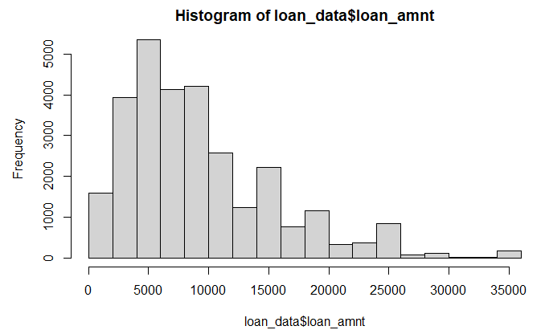

**hist_1$breaks**

[1] 0 2000 4000 6000 8000 10000 12000 14000 16000 18000 20000 22000 24000 26000 28000 30000

[17] 32000 34000 36000

**hist_2 <- hist(loan_data$loan_amnt, breaks = 200, xlab = "Loan amount", main = "Histogram of the loan amount")**

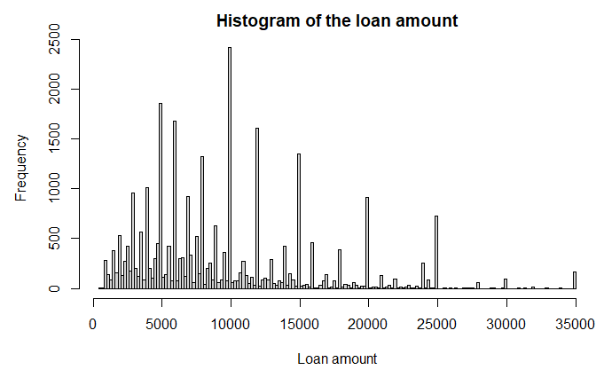

Outliers:

**hist(loan_data$age)**

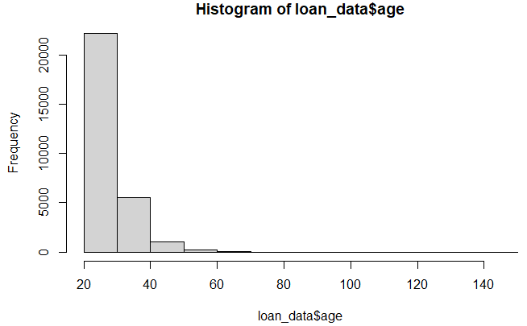

**plot(loan_data$age, ylab = "Age")**

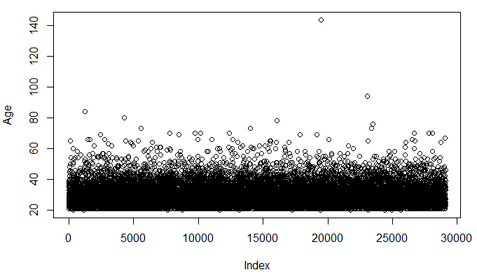

The oldest person in this data set is older than 122 years! Get the index of this outlier using which() and the age of 122 as a cutoff (you can do this using loan_data$age > 122). Assign it to the object index_highage.

**index_highage <- which(loan_data$age > 122)**

Create a new data set new_data, after removing the observation with the high age using the object index_highage.

**new_data <- loan_data[-index_highage, ]**

The bivariate scatterplot, with age on the x-axis and annual income on the y-axis.

**plot(loan_data$age, loan_data$annual_inc, xlab = "Age", ylab = "Annual Income")**

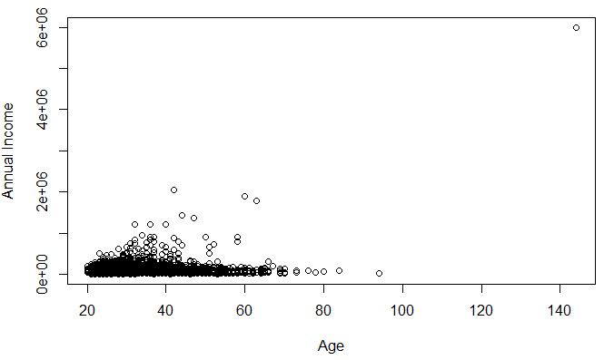

**STEP 5: EXAMINE MISSING DATA FROM THE DATASET**

The interest rate (int_rate) in the data set loan_data depends on the customer. Unfortunately some observations are missing interest rates. You now need to identify how many interest rates are missing and then delete them.

**summary(loan_data$int_rate)**

Min. 1st Qu. Median Mean 3rd Qu. Max. NA's

5.42 7.90 10.99 11.00 13.47 23.22 2776

# Get indices of missing interest rates: na_index

**na_index <- which(is.na(loan_data$int_rate))**

# Remove observations with missing interest rates: loan_data_delrow_na

**loan_data_delrow_na <- loan_data[-na_index, ]**

# Make copy of loan_data

**loan_data_delcol_na <- loan_data**

# Delete interest rate column from loan_data_delcol_na

**loan_data_delcol_na$int_rate <- NULL**

**Step 5: Replacing Missing data in the dataset**

Create an object called median_ir, containing the median of the interest rates in loan_data using the median() function. Include the argument na.rm = TRUE.

# Compute the median of int_rate

**median_ir <- median(loan_data$int_rate, na.rm = TRUE)**

# Make copy of loan_data

**loan_data_replace <- loan_data**

# Replace missing interest rates with median

**loan_data_replace$int_rate[na_index] <- median_ir**

# Check if the NAs are gone

**summary(loan_data_replace$int_rate)**

Min. 1st Qu. Median Mean 3rd Qu. Max.

5.42 8.49 10.99 11.00 13.11 23.22

|  |  |
| --- | --- |
| AIM & DATASET DESCRIPTION | /25 |
| ALGORITHM | /20 |
| PROCEDURE | /45 |
| VIVA | /10 |
| TOTAL | /100 |

**RESULT**:

Thus the Prediction of Credit Risk Using Linear Regression is implemented in R studio

|  |  |
| --- | --- |
| **Ex.No:3** | **HR ANALYTICS TO PREDICT THE DEMAND FOR HOURLY-EMPLOYEES** |
|  |

**AIM**:

To apply HR analytics to make a prediction of the demand for hourly-employees for the

following month using R Programming.

**ALGORITHM:**

Step 1: Import Data using CSV file.

Step 2: Do data cleaning.

Step 3: Renaming the irrelevant variable name.

Step 4: Perform exploratory data analysis.

Step 5: Perform statistical test for correlation.

Step 6: Display distribution plots on the basis of Satisfaction, Evaluation and Average Monthly.

**PROCEDURE:**

**STEP 1: IMPORT DATA USING CSV FILE.**

**data<-read.csv('D:/hr.csv')**

**STEP 2: DO DATA CLEANING.**

**summary(data)**

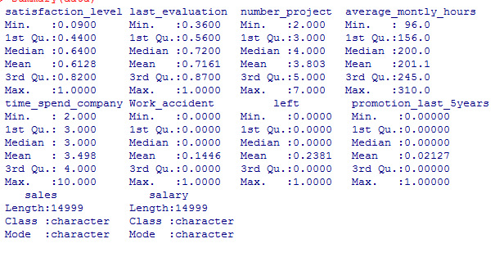

**STEP 3: RENAMING THE IRRELEVANT VARIABLE NAME.**

**install.packages(“plyr”)**

**library(plyr)**

**data<-rename(data, c("sales"="role"))**

**data<-rename(data, c("time_spend_company"="exp_in_company"))**

**names(data)[10]<-"salary"**

**head(data)**

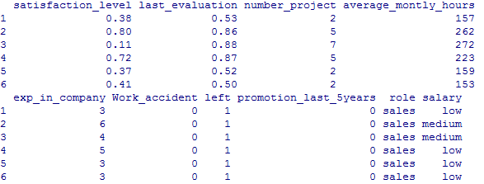

**STEP 4: PERFORM EXPLORATORY DATA ANALYSIS.**

**dim(data)**

*[1] 14999 10*

**str(data)**

'data.frame': 14999 obs. of 10 variables:

$ satisfaction_level : num 0.38 0.8 0.11 0.72 0.37 0.41 0.1 0.92 0.89 0.42 ...

$ last_evaluation : num 0.53 0.86 0.88 0.87 0.52 0.5 0.77 0.85 1 0.53 ...

$ number_project : int 2 5 7 5 2 2 6 5 5 2 ...

$ average_montly_hours : int 157 262 272 223 159 153 247 259 224 142 ...

$ exp_in_company : int 3 6 4 5 3 3 4 5 5 3 ...

$ Work_accident : int 0 0 0 0 0 0 0 0 0 0 ...

$ left : int 1 1 1 1 1 1 1 1 1 1 ...

$ promotion_last_5years: int 0 0 0 0 0 0 0 0 0 0 ...

$ role : chr "sales" "sales" "sales" "sales" ...

$ salary : chr "low" "medium" "medium" "low" ...

**attrition<-as.factor(data$left)**

**summary(attrition)**

*0 1*

*11428 3571*

**perc_attrition_rate<-sum(data$left/length(data$left))*100**

**print(perc_attrition_rate)**

*[1] 23.80825*

**cor_vars<data[,c("satisfaction_level","last_evaluation","number_project","average_montly_hours","exp_in_company","Work_accident","left","promotion_last_5years")]**

**aggregate(cor_vars[,c("satisfaction_level","last_evaluation","number_project","average_montly_hours","exp_in_company","Work_accident","promotion_last_5years")], by=list(Category=cor_vars$left), FUN=mean)**

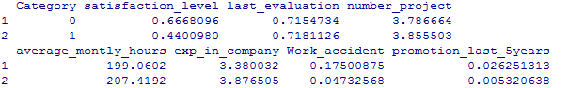

**install.packages("reshape2")**

**library(reshape2)**

**library(ggplot2)**

**cor_vars<data[,c("satisfaction_level","last_evaluation","number_project","average_montly_hours","exp_in_company","Work_accident","left","promotion_last_5years")]**

**cor(cor_vars)**

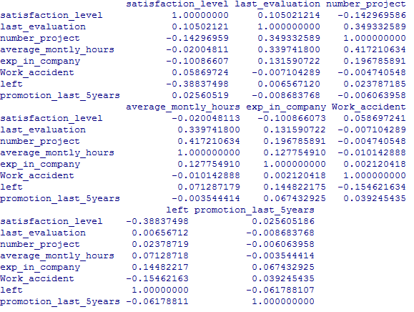

**trans<-cor(cor_vars)**

**melted_cormat <- melt(trans)**

**ggplot(data = melted_cormat, aes(x=Var1, y=Var2, fill=value))+ geom_tile() +theme(axis.text.x = element_text(angle = 90, hjust = 1))**

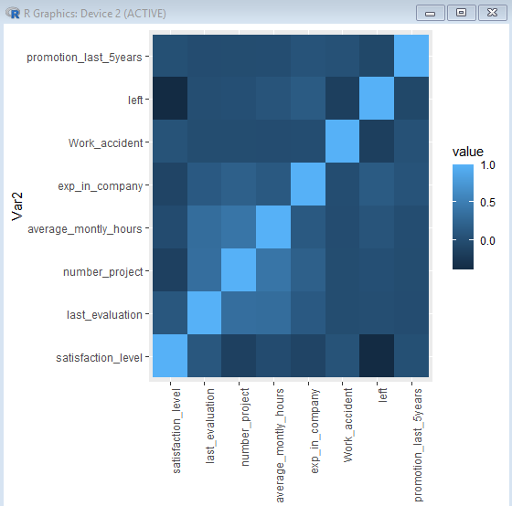

**STEP 5: PERFORM STATISTICAL TEST FOR CORRELATION.**

**emp_population_satisfaction <-mean(data$satisfaction_level)**

**left_pop<-subset(data,left==1)**

**print( c('The mean for the employee population is: ', emp_population_satisfaction) )**

*[1] "The mean for the employee population is: "*

*[2] "0.612833522234816"*

**print( c('The mean for the employees that had a turnover is: ' ,emp_turnover_satisfaction) )**

*[1] "The mean for the employees that had a turnover is: "*

*[2] "0.440098011761411"*

**t.test(left_pop$satisfaction_level,mu=emp_population_satisfaction)**

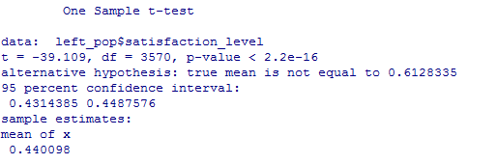

**STEP 6: DISPLAY DISTRIBUTION PLOTS ON THE BASIS OF SATISFACTION, EVALUATION AND AVERAGE MONTHLY.**

**> par(mfrow=c(1,3))**

**> hist(data$satisfaction_level, col="green")**

**> hist(data$last_evaluation, col="red")**

**> hist(data$average_montly_hours, col="blue")**

|  |  |
| --- | --- |
| AIM & DATASET DESCRIPTION | /25 |
| ALGORITHM | /20 |
| PROCEDURE | /45 |
| VIVA | /10 |
| TOTAL | /100 |

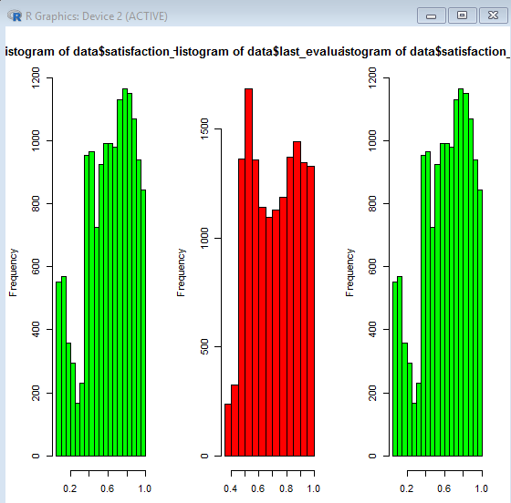

**RESULT:**

Thus the HR Analytics to Predict the Demand for Hourly-Employees is implemented in R Studio

|  |  |
| --- | --- |
| **Ex.No:4** | **APPLY ANALYTICS FOR FORECASTING AIR PASSENGERS** |
|  |

**AIM:**

The dataset consists of monthly totals of international airline passengers, 1949 to 1960.Main aim is to predict next ten years.

**ALGORITHM:**

Step 1: Load Data

Step 2: Test the stationarity of time series

Step 3: Make it stationary

Step 4: Time Series Decomposition

Step 5: Model Identification and Estimation

Stepn 6: ARIMA Model Prediction

Step 7: Check normality using Q-Q plot

**PROCEDURE:**

**STEP 1: LOAD DATA**

**loading library dplyr**

**library(tseries)**

**library(forecast)**

**data(AirPassengers)**

**AirPassengers**

## Jan Feb Mar Apr May Jun Jul Aug Sep Oct Nov Dec

## 1949 112 118 132 129 121 135 148 148 136 119 104 118

## 1950 115 126 141 135 125 149 170 170 158 133 114 140

## 1951 145 150 178 163 172 178 199 199 184 162 146 166

## 1952 171 180 193 181 183 218 230 242 209 191 172 194

## 1953 196 196 236 235 229 243 264 272 237 211 180 201

#The dataset shows the number of passengers travelling on a flight for all the months in a year.

**class(AirPassengers)**

## [1] "ts"

**end(AirPassengers)**

## [1] 1960 12

Check for missing values

**sum(is.na(AirPassengers))**

## [1] 0

cycle of this time series is 12 months in a year

**frequency(AirPassengers)**

## [1] 12

**Summary**

**summary(AirPassengers)**

## Min. 1st Qu. Median Mean 3rd Qu. Max.

## 104.0 180.0 265.5 280.3 360.5 622.0

**SETP 2: TEST THE STATIONARITY OF TIME SERIES**

In order to test the stationarity of the time series, let’s run the Augmented Dickey-Fuller Test using the adf.test function from the tseries R package.

First set the hypothesis test:

The null hypothesis : time series is non stationary

The alternative hypothesis : time series is stationary

***adf.test(AirPassengers, alternative ="stationary", k=12)***

## Augmented Dickey-Fuller Test

## data: AirPassengers

## Dickey-Fuller = -1.5094, Lag order = 12, p-value = 0.7807

## alternative hypothesis: stationary

As a rule of thumb, where the p-value is less than 0.05, strong evidence against the null hypothesis, so we reject the null hypothesis. From the above p-value, we concluded that the time series is non-stationary .

#Below plot shows how they vary with time.

***plot(AirPassengers,main="Air Passenger numbers from 1949 to 1961") #show sparkine***

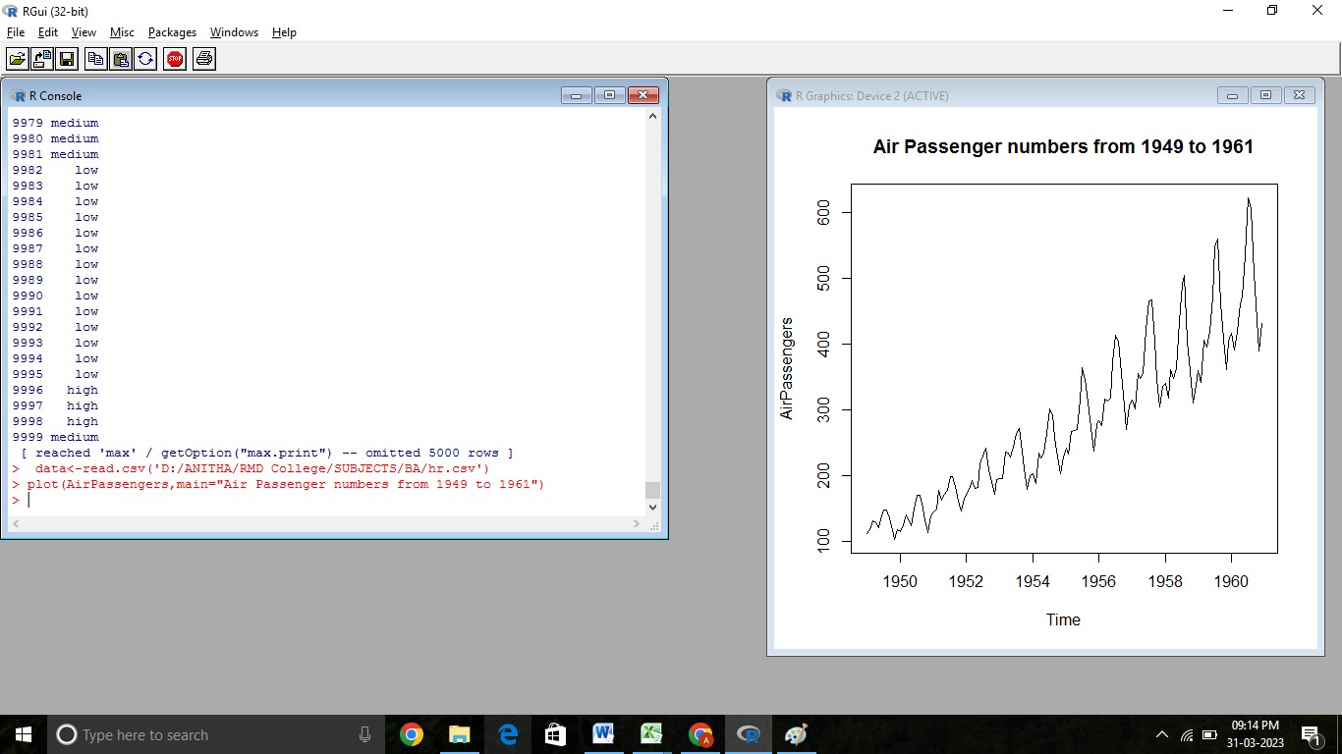

***plot(AirPassengers)+abline(reg=lm(AirPassengers~time(AirPassengers)))***

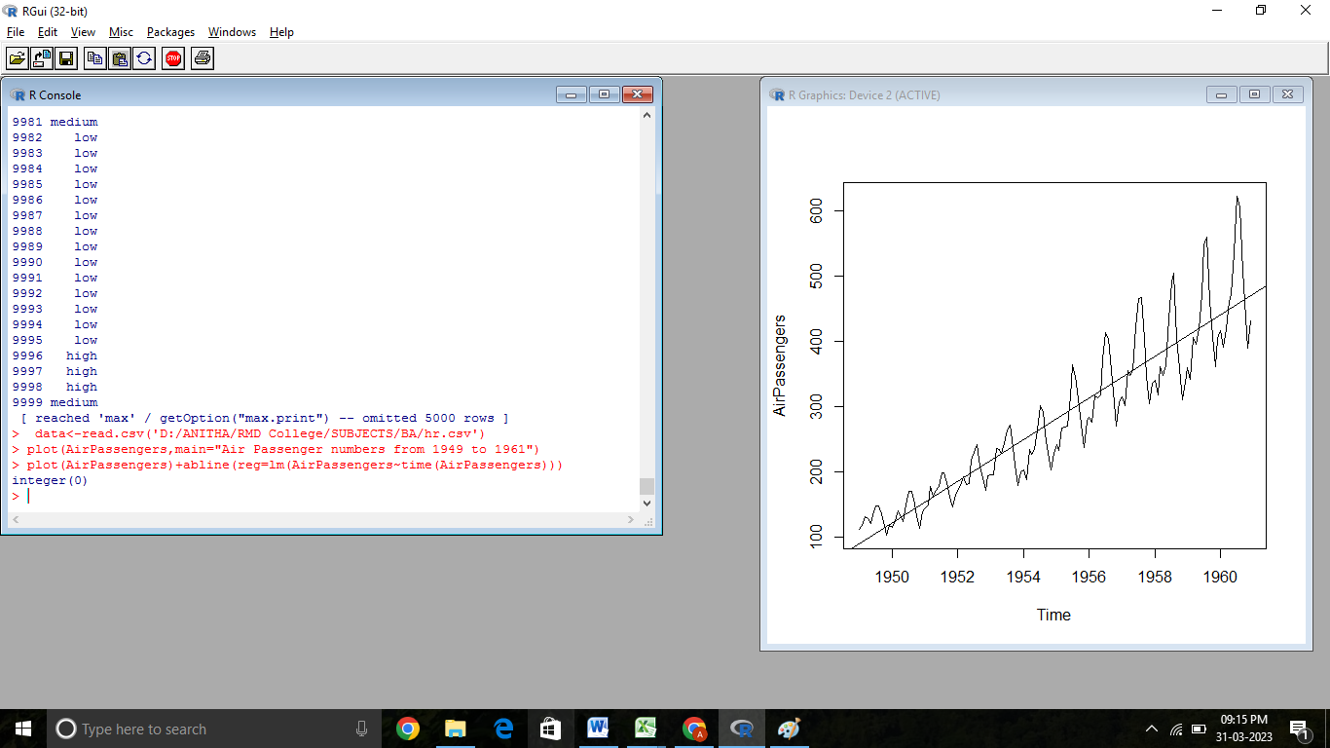

## integer(0)

from graph you can see at every point of time variance is changing.Variance means you can see difference between trendline and sparkline.Here variance and mean is also increasing, hence it is not stationary.

**STEP 3: MAKE IT STATIONARY**

stationary means there should be consitant mean and variance

We need to address two issue before we test stationary series 1.Remove unequal variance using log of time series 2.Address the trend componant, do this by taking difference

***plot(log(AirPassengers))***

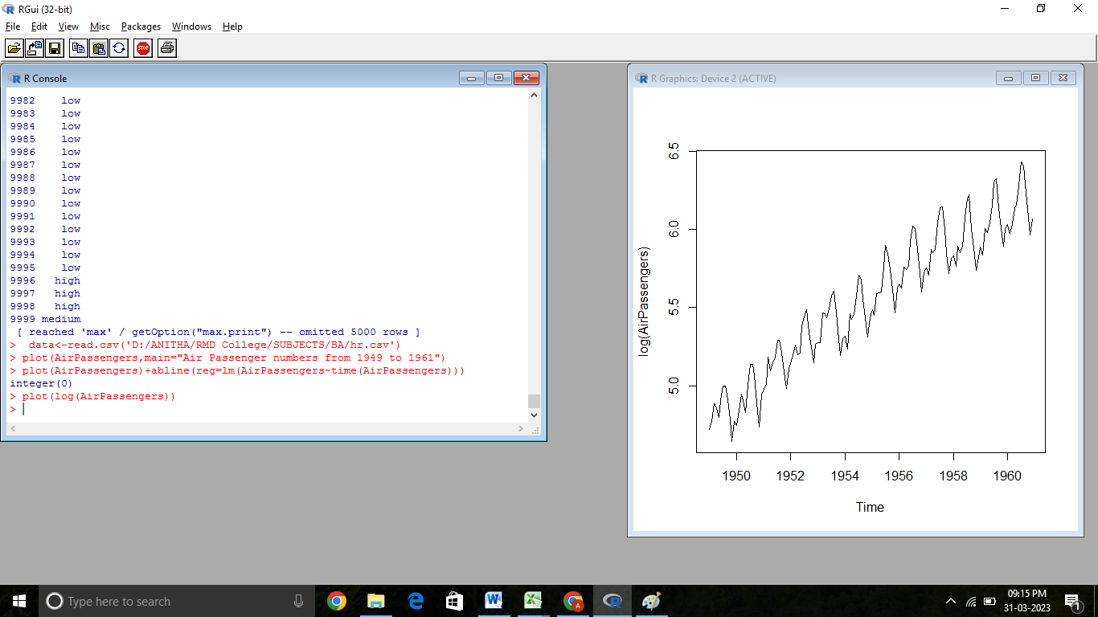

***plot(diff(log(AirPassengers)))***

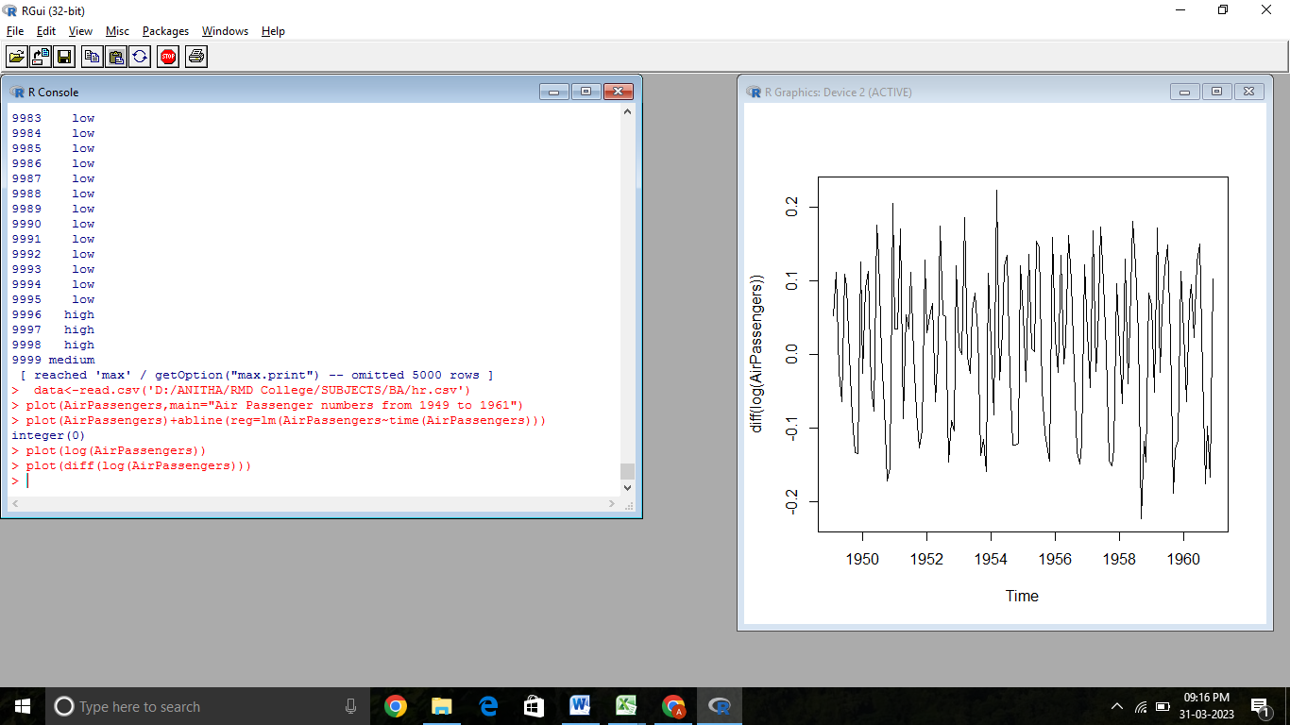

#Now you can see mean and variance both are stationary

#Check general trend.

***plot(aggregate(AirPassengers,FUN = mean))***

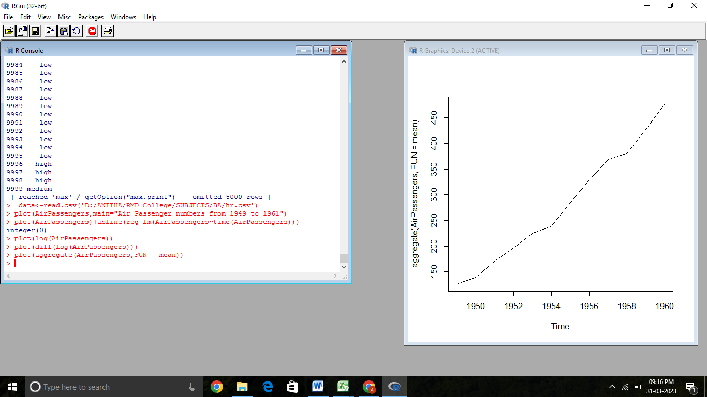

#It is upword trend

Use the boxplot function to see any seasonal effects.

#Show seasonality

***boxplot(AirPassengers~cycle(AirPassengers))***

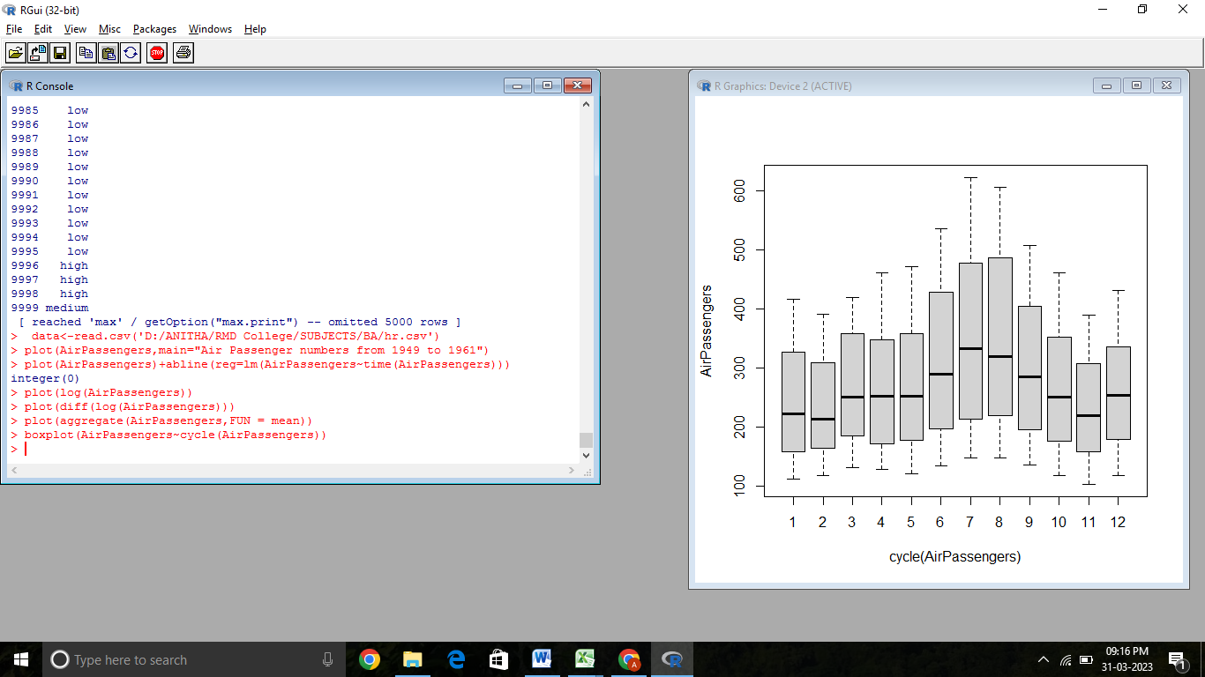

In the boxplot you can see in month july and aug no of passangers traveling are more. The rationale for this could be more people taking holidays and fly over the summer months

**STEP 4: TIME SERIES DECOMPOSITION**

#Decomposition break data into trend, seasonal, regular and random

***plot(decompose(AirPassengers)) # time series decomposition***

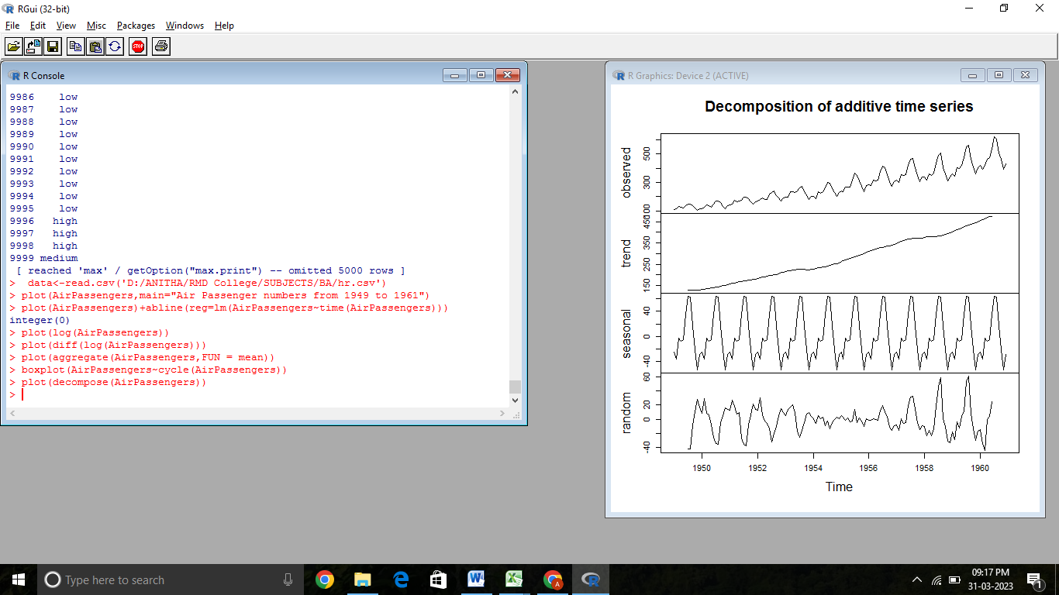

The above figure shows the time series decomposition into trend, seasonal and random (noise) . It is clear that the time series is non-stationary (has random walks) because of seasonal effects and a trend (linear trend).

**STEP 5: MODEL IDENTIFICATION AND ESTIMATION**

***tsdata <- ts(log(AirPassengers),frequency = 12)***

Calculate p d q value

AR(Autoregreesive) :- by seeing the past value, predict own value Integration

MA(Moving Average) :- you take diff intervals and calculate the average Autocorrelation function and partial autocorrelation function to determine value of p and q

Autocorrelation is the linear dependence of a variable with itself at two points in time Auto correlation function, as the word suggests, auto-correlation, means it is really correlation on itself.With time series we just have a single stream of values, or in other words there is just the X no Y.

So suppose your time series is like this X = 3,5,6,6,7,4,5,6,7,2,3,4,. correlation between 4 and 3, 3 and 2, 2 and 7 (lag 1) will be say y1; correlation between 4 and 2, 3 and 7, 2 and 6 (lag 2) will be say y2; and so on at lags 3 = y3, lag 4 = y4.

***acf(AirPassengers)***

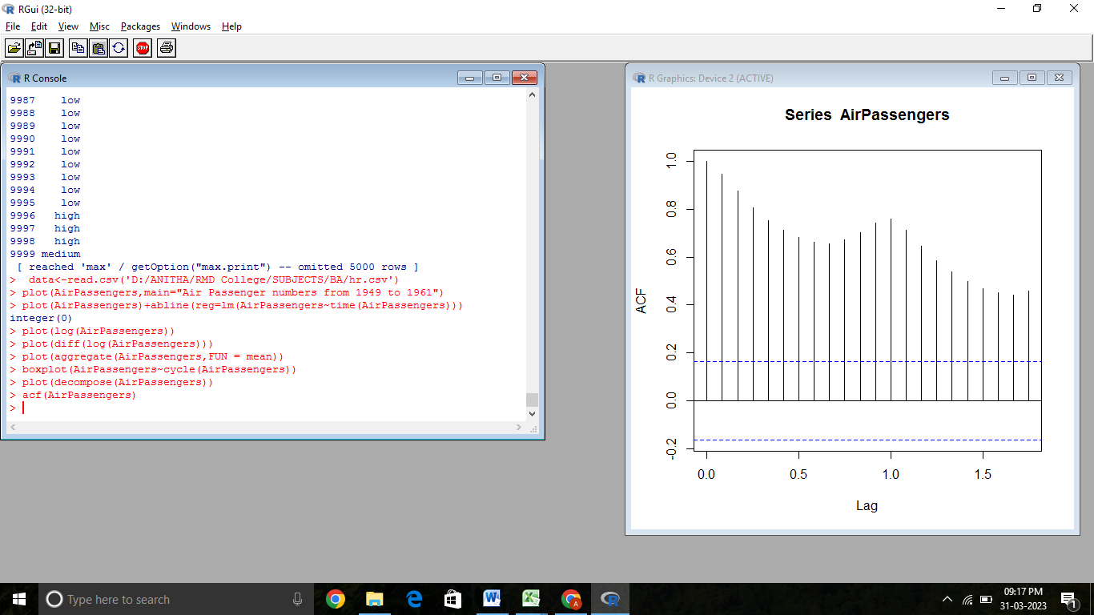

***acf(diff(log(AirPassengers)))***

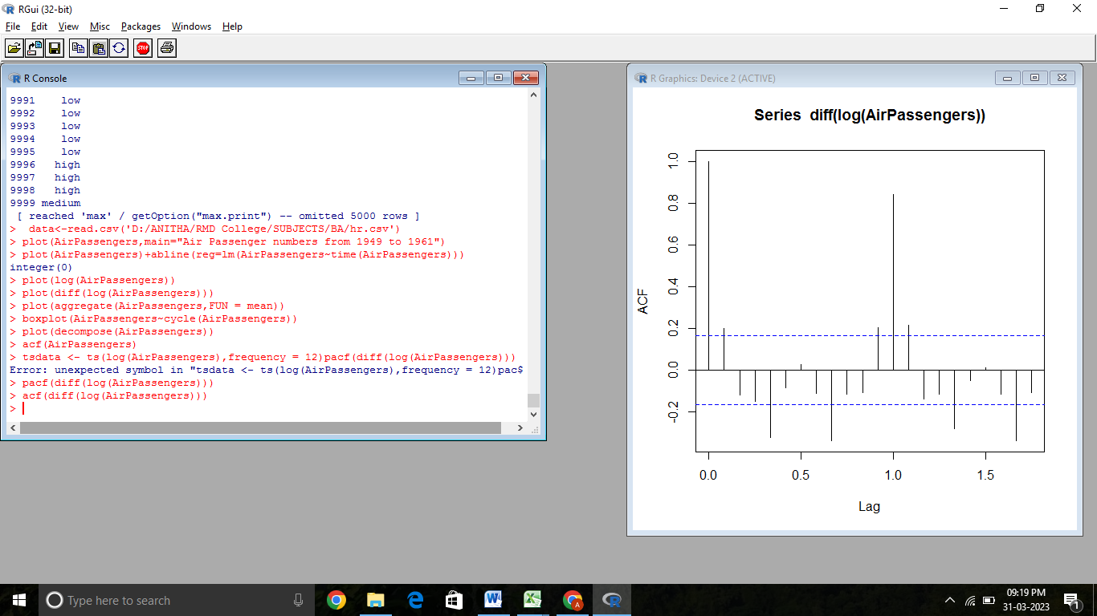

Partial auto correlation function, as the word suggests, is partial not complete. Here again we are plot the correlations at various lags 1,2,3 BUT after adjusting for the effects of intermediate numbers.

***pacf(diff(log(AirPassengers)))***

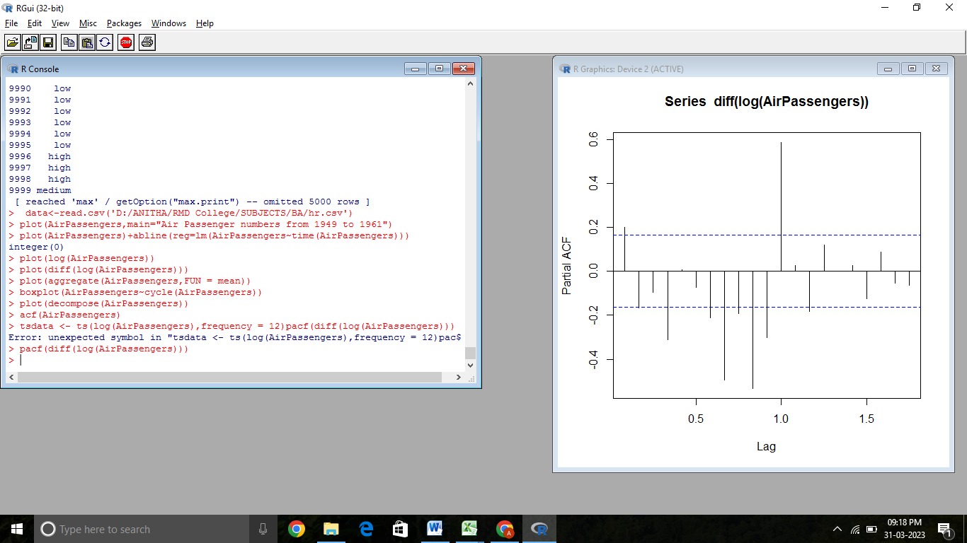

#It determine value of p (value we got as 0)

#d is number of time you do the differentiations to make the mean

#We do diff only one time so value of d is 1

***plot(diff(log(AirPassengers)))***

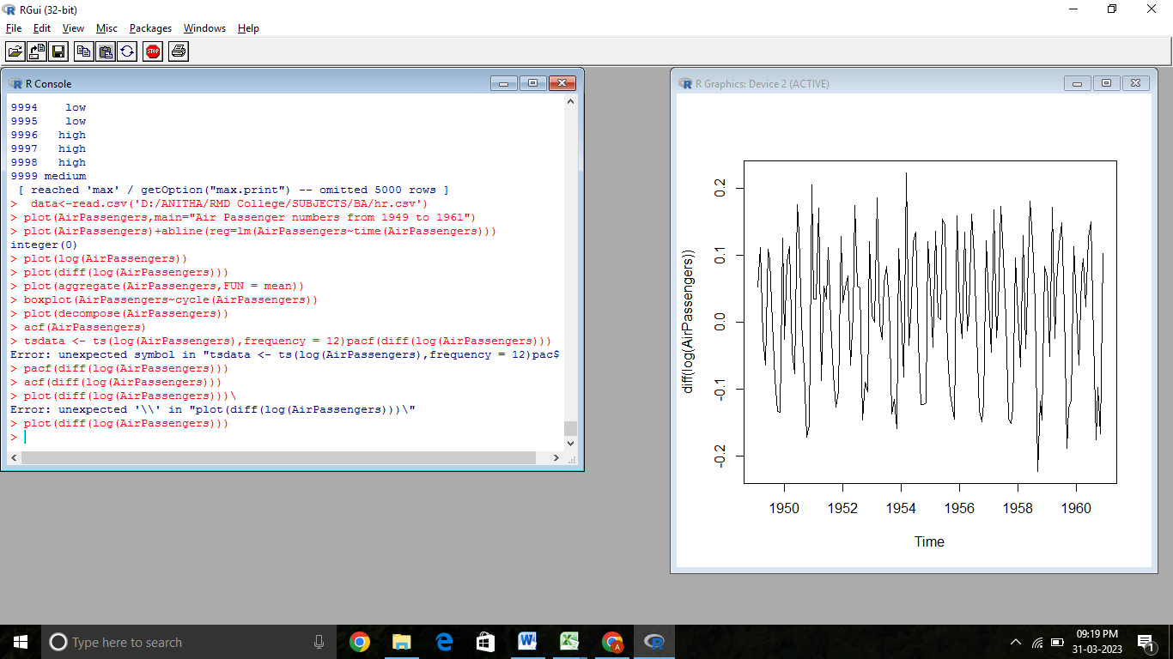

**STEPN 6: ARIMA MODEL PREDICTION**

**fit <- arima(log(AirPassengers),c(0,1,1),seasonal = list(order=c(0,1,1),period=12))**

*fit*

## Call:

## arima(x = log(AirPassengers), order = c(0, 1, 1), seasonal = list(order = c(0,

## 1, 1), period = 12))

## Coefficients:

## ma1 sma1

## -0.4018 -0.5569

## s.e. 0.0896 0.0731

## sigma^2 estimated as 0.001348: log likelihood = 244.7, aic = -483.4

Predict for next 10 years

***pred <- predict(fit,n.ahead=10*12) #10 years * 12 months***

***pred***

## $pred

## Jan Feb Mar Apr May Jun Jul

## 1961 6.110186 6.053775 6.171715 6.199300 6.232556 6.368779 6.507294

## 1962 6.206435 6.150025 6.267964 6.295550 6.328805 6.465028 6.603543

## 1963 6.302684 6.246274 6.364213 6.391799 6.425054 6.561277 6.699792

## 1964 6.398934 6.342523 6.460463 6.488048 6.521304 6.657526 6.796042

## 1965 6.495183 6.438772 6.556712 6.584297 6.617553 6.753776 6.892291

## 1966 6.591432 6.535022 6.652961 6.680547 6.713802 6.850025 6.988540

## 1967 6.687681 6.631271 6.749210 6.776796 6.810052 6.946274 7.084789

## 1968 6.783931 6.727520 6.845460 6.873045 6.906301 7.042523 7.181039

## 1969 6.880180 6.823769 6.941709 6.969295 7.002550 7.138773 7.277288

## 1970 6.976429 6.920019 7.037958 7.065544 7.098799 7.235022 7.373537

The above output prediction value are in logarithemic part,convert them to original form we need to transform them.

#2.718 is e value and round them to 0 decimal

***pred1<-round(2.718^pred$pred,0)***

***pred1***

*#give op of 1960 to 1970*

## Jan Feb Mar Apr May Jun Jul Aug Sep Oct Nov Dec

## 1961 450 425 479 492 509 583 670 667 558 497 430 477

## 1962 496 468 527 542 560 642 737 734 614 547 473 525

## 1963 546 516 580 597 617 707 812 808 676 602 521 578

## 1964 601 568 639 657 679 778 894 890 745 663 573 637

## 1965 661 625 703 723 748 857 984 980 820 730 631 701

## 1966 728 688 775 796 823 943 1083 1079 903 804 695 772

## 1967 802 758 853 877 906 1039 1193 1188 994 885 765 850

## 1968 883 834 939 965 998 1143 1313 1308 1094 975 843 935

## 1969 972 919 1034 1063 1099 1259 1446 1440 1205 1073 928 1030

## 1970 1070 1012 1138 1170 1210 1386 1592 1585 1326 1181 1021 1134

plot this model

#line type (lty) can be specified using either text ("blank", "solid", "dashed", "dotted", "dotdash", "longdash", "twodash") or number (0, 1, 2, 3, 4, 5, 6). Note that lty = "solid" is identical to lty=1.

***ts.plot(AirPassengers,pred1,log="y",lty=c(1,3))***

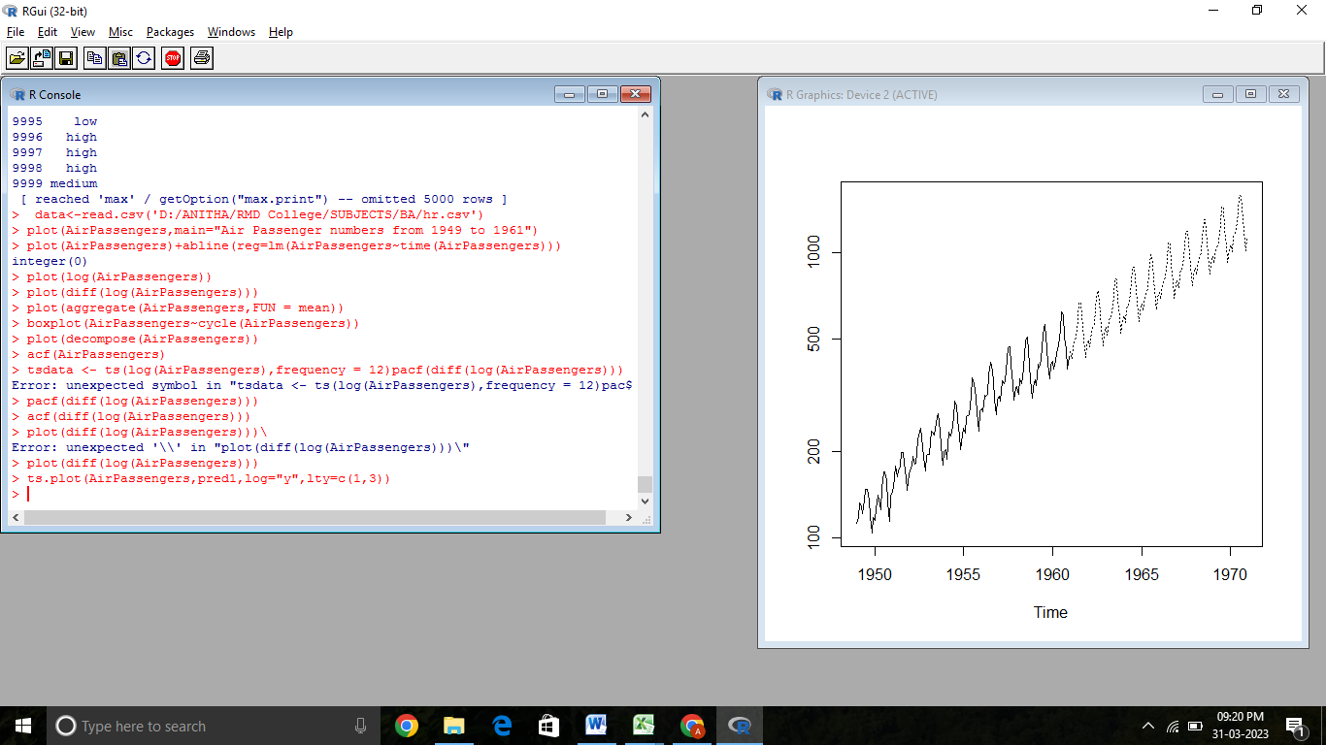

In above graph, dark(solid) line is original values and dotted are predicted values

Compare predicted values with original values

#Get only 1961 values

***data1<-head(pred1,12)***

***data1***

## Jan Feb Mar Apr May Jun Jul Aug Sep Oct Nov Dec

## 1961 450 425 479 492 509 583 670 667 558 497 430 477

predicted almost close values to Original values

#Predicted Values

***predicted_1960 <- round(data1)#head of Predicted***

***predicted_1960***

## Jan Feb Mar Apr May Jun Jul Aug Sep Oct Nov Dec

## 1961 450 425 479 492 509 583 670 667 558 497 430 477

#Original

***original_1960 <- tail(AirPassengers,12) #tail of original***

**original_1960**

## Jan Feb Mar Apr May Jun Jul Aug Sep Oct Nov Dec

## 1960 417 391 419 461 472 535 622 606 508 461 390 432

Lets Test this Model we are going to take a dataset till 1959, and then we predict value of 1960, then validate that 1960 from alredy existing value we have it in dataset

#Recreate model till 1959

***datawide <- ts(AirPassengers, frequency = 12, start=c(1949,1), end=c(1959,12))***

***datawide***

## Jan Feb Mar Apr May Jun Jul Aug Sep Oct Nov Dec

## 1949 112 118 132 129 121 135 148 148 136 119 104 118

## 1950 115 126 141 135 125 149 170 170 158 133 114 140

## 1951 145 150 178 163 172 178 199 199 184 162 146 166

## 1952 171 180 193 181 183 218 230 242 209 191 172 194

## 1953 196 196 236 235 229 243 264 272 237 211 180 201

## 1954 204 188 235 227 234 264 302 293 259 229 203 229

## 1955 242 233 267 269 270 315 364 347 312 274 237 278

## 1956 284 277 317 313 318 374 413 405 355 306 271 306

## 1957 315 301 356 348 355 422 465 467 404 347 305 336

## 1958 340 318 362 348 363 435 491 505 404 359 310 337

## 1959 360 342 406 396 420 472 548 559 463 407 362 405

#Create model

**fit1 <- arima(log(datawide),c(0,1,1),seasonal = list(order=c(0,1,1),period=12))**

**pred <- predict(fit1,n.ahead=10*12) # predictfor now 1960 to 1970**

**pred1<-2.718^pred$pred**

**pred1**

*#give op of 1960 to 1970*

## Jan Feb Mar Apr May Jun Jul

## 1960 419.0628 398.6732 466.2820 454.1188 472.9611 546.7614 621.8017

## 1961 469.5742 446.7270 522.4849 508.8558 529.9692 612.6649 696.7502

## 1962 526.1740 500.5730 585.4623 570.1903 593.8487 686.5121 780.7325

## 1963 589.5961 560.9092 656.0306 638.9179 665.4278 769.2603 874.8376

## 1964 660.6627 628.5180 735.1048 715.9294 745.6347 861.9826 980.2855

## 1965 740.2952 704.2761 823.7102 802.2235 835.5093 965.8811 1098.4436

## 1966 829.5262 789.1655 922.9956 898.9190 936.2169 1082.3030 1230.8438

## 1967 929.5126 884.2870 1034.2482 1007.2696 1049.0631 1212.7576 1379.2027

## 1968 1041.5507 990.8740 1158.9107 1128.6801 1175.5113 1358.9366 1545.4440

## 1969 1167.0934 1110.3083 1298.5992 1264.7248 1317.2007 1522.7351 1731.7230

***data11=round(head(pred1,12),0) #head of Predicted***

***data22=round(tail(AirPassengers,12),0) #tail of original***

***plot(data11,col="red", type="l")***

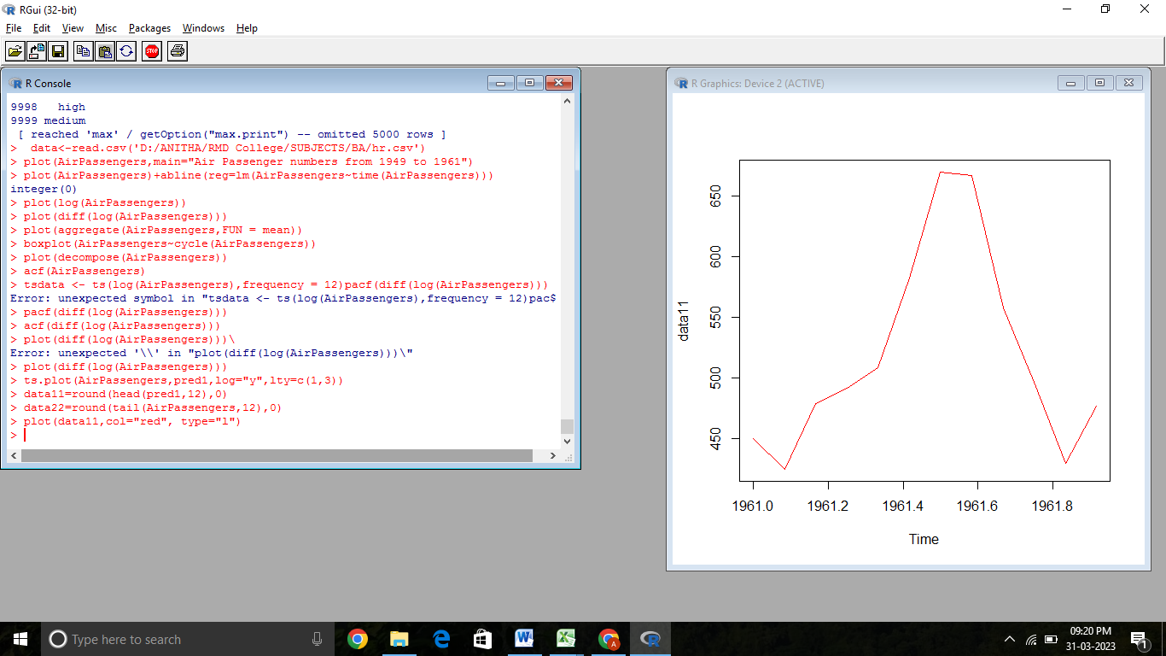

***lines(data22,col="blue")***

**STEP 7: CHECK NORMALITY USING Q-Q PLOT**

qqnorm is a generic function the default method of which produces a normal QQ plot of the values in y. qqline adds a line to a “theoretical”, by default normal, quantile-quantile plot which passes through the probs quantiles, by default the first and third quartiles.

***qqnorm(residuals(fit))***

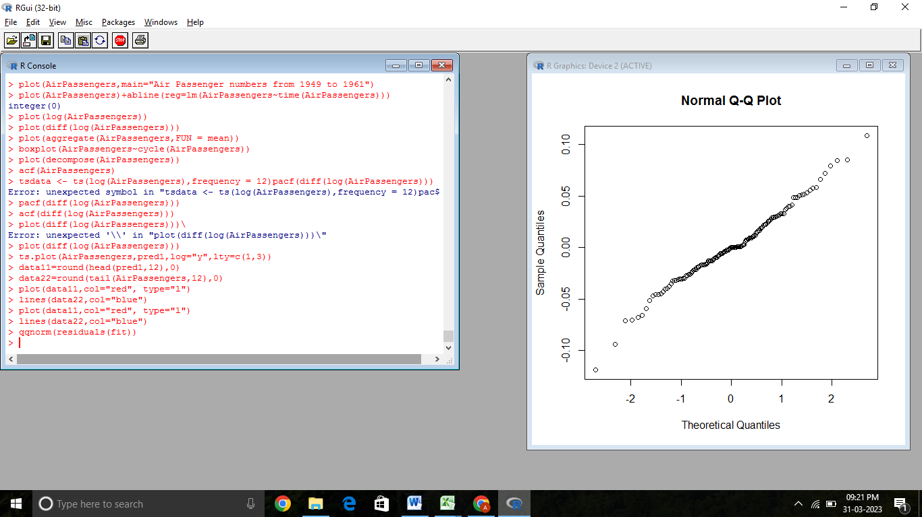

***qqline(residuals(fit))***

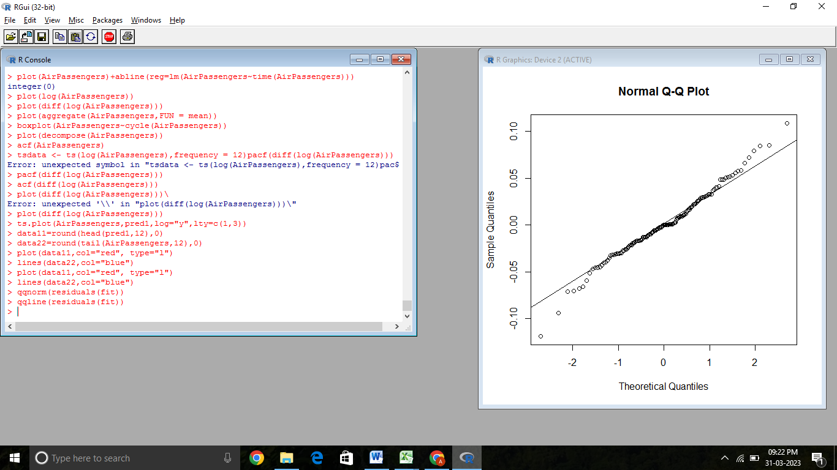

The linearity of the points suggests that the data are normally distributed with mean = 0

|  |  |
| --- | --- |
| AIM & DATASET DESCRIPTION | /25 |
| ALGORITHM | /20 |
| PROCEDURE | /45 |
| VIVA | /10 |
| TOTAL | /100 |

**RESULT:**

Thus the Apply Analytics for Forecasting Air Passengers is implemented successfully in R studio.

|  |  |
| --- | --- |
| **Ex.No:5** | **APPLY ANALYTICS FOR FORECASTING AND INVENTORY PLANNING FOR**  **A LARGE RETAILER** |
|  |

**AIM:**

To apply analytics for forecasting and inventory planning for a large retailer.

**DATASET DESCRIPTION**

For a long time, Apple such as iPad they look elegant and easy to use. Even the last few product kind disappointed. One thing lead to another, this makes to think how well Apple’s stock in the market. With this article, we try to make a model to predict their stock value in the future.

**ALGORITHM:**

Step 1: Load all necessary libraries

Step 2: Import data and read data from Apple Stock Dataset

Step 3: Check if the data has missing value or not.

Step 4: Cleanse the dataset

**PROCEDURE:**

**STEP 1: LOAD ALL NECESSARY LIBRARIES**

library(dplyr) *# data wrangling*

library(lubridate) *# date manipulation*

library(forecast) *# time series library*

library(MLmetrics) *# calculate error*

library(ggplot2) *# Beautify the graph*

library(tidyr) *# Tidy the data*

library(zoo) *# Order index observations*

library(tseries) *# adf.test*

**STEP 2: IMPORT DATA AND READ DATA FROM APPLE STOCK DATASET**

*# Read data*

**AAPL <- read.csv("AAPL.csv")**

*# Check the data*

**AAPL %>% head()**

#> Date Open High Low Close Adj.Close Volume

#> 1 1980-12-12 0.128348 0.128906 0.128348 0.128348 0.100178 469033600

#> 2 1980-12-15 0.122210 0.122210 0.121652 0.121652 0.094952 175884800

#> 3 1980-12-16 0.113281 0.113281 0.112723 0.112723 0.087983 105728000

#> 4 1980-12-17 0.115513 0.116071 0.115513 0.115513 0.090160 86441600

#> 5 1980-12-18 0.118862 0.119420 0.118862 0.118862 0.092774 73449600

#> 6 1980-12-19 0.126116 0.126674 0.126116 0.126116 0.098436 48630400

change Date datatype. Select the column we need (Date, Close). Then complete the date, so it appears sequentially.

**AAPL <- AAPL %>%**

**mutate(Date = ymd(Date)) %>%**

**select(c(Date, Close)) %>%**

**complete(Date = seq.Date(min(Date), max(Date), by="day")) %>%**

**arrange()**

**AAPL %>% head()**

#> # A tibble: 6 × 2

#> Date Close

#> <date> <dbl>

#> 1 1980-12-12 0.128

#> 2 1980-12-13 NA

#> 3 1980-12-14 NA

#> 4 1980-12-15 0.122

#> 5 1980-12-16 0.113

#> 6 1980-12-17 0.116

**AAPL %>% tail()**

#> # A tibble: 6 × 2

#> Date Close

#> <date> <dbl>

#> 1 2022-06-12 NA

#> 2 2022-06-13 132.

#> 3 2022-06-14 133.

#> 4 2022-06-15 135.

**STEP 3: CHECK IF THE DATA HAS MISSING VALUE OR NOT.**

*# Check missing value*

**AAPL %>% is.na() %>% colSums()**

#> Date Close

#> 0 4695

The data has missing value

Inspect the data with plot graph

**AAPL$Close %>% tail(200) %>%**

**plot(type="l", col = "blue", lwd = 2, xlab = "time (days)", ylab = 'Close', main = "Stock Market Close")**

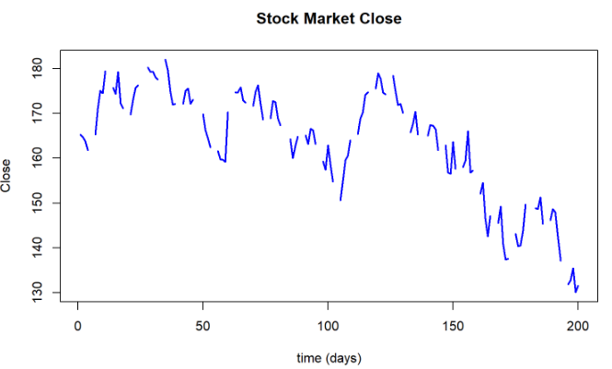

We cann**ot** use the data like that. Because time series data must appear sequentially. Main requirements for time series data:

(1) The data must be sorted according to the time period from the oldest data to the newest data

(2) The time interval must be the same

(3) No missing data for each interval

(4) Lastly, nothing can be missing on the dataset

**library(zoo)**

**AAPL_new <- AAPL %>%**

**mutate(Close = na.fill(Close, "extend"))** *# Fill the missing value with "extend"*

**AAPL_new %>%**

**tail(200) %>%** *# get the last 200 data*

**plot(type="l", col = "blue", lwd = 2, xlab = "time (days)", ylab = 'Close', main = "Stock Market Close")**

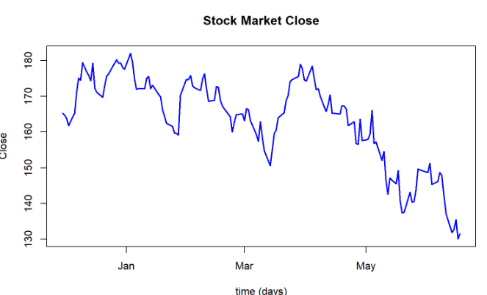

Check the whole dataset with plot

**AAPL_new %>%**

**plot(type="l", col = "blue", lwd = 2, xlab = "time (years)", ylab = 'Close', main = "Stock Market Close")**

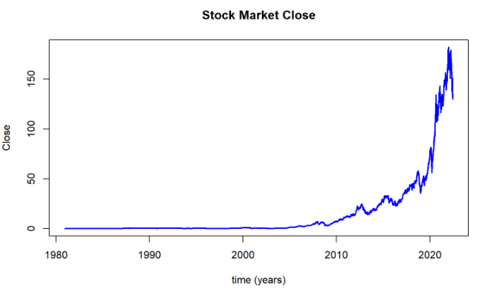

Check the last 6 observations in dataset with plot

**AAPL_new %>% tail() %>%**

**plot(type="l", col = "blue", lwd = 2, xlab = "time (days)", ylab = 'Close', main = "Stock Market Close")**

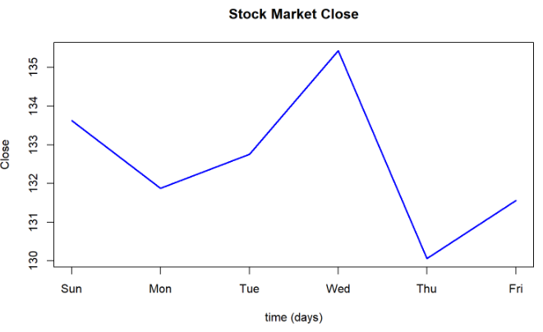

The graph already connected, we can continue the process.

**STEP 4: CLEANSE THE DATASET**

Check data class AAPL_new

**class(AAPL_new)**

#> [1] "tbl_df" "tbl" "data.frame"

The dataset has observation with day by day. We could make to month by month. So, the analysis more applicable to the problem.

**APPL_m <- AAPL_new %>% group_by(month = lubridate::floor_date(Date, "month")) %>% summarize(Close = mean(Close))**

**APPL_m %>% head()**

#> # A tibble: 6 × 2

#> month Close

#> <date> <dbl>

#> 1 1980-12-01 0.137

#> 2 1981-01-01 0.142

#> 3 1981-02-01 0.118

#> 4 1981-03-01 0.111

#> 5 1981-04-01 0.121

#> 6 1981-05-01 0.131

**STEP 5: TIME SERIES MODELLING ANALYSIS**

*Make our data to Object TS / Time Series*

***AAPL_ts <- ts( data = APPL_m$Close, start = c(1980,12,01), frequency = 12)***

***class(AAPL_ts)***

*#> [1] "ts"*

We successfuly make our data APPL_m to ts (time series).

*Plot AAPL_ts*

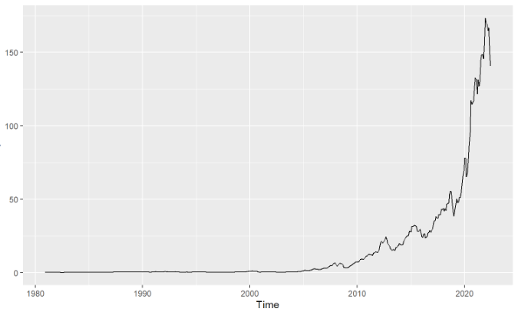

**STEP 6: CROSS VALIDATION**

*Cross Validation by splitting Data Train and Data Test.*

*# test*

***AAPL_test <- tail(AAPL_w, 24)***

*# train*

***AAPL_train <- head(AAPL_w, -length(AAPL_test))***

*Check AAPL_train with visualization*

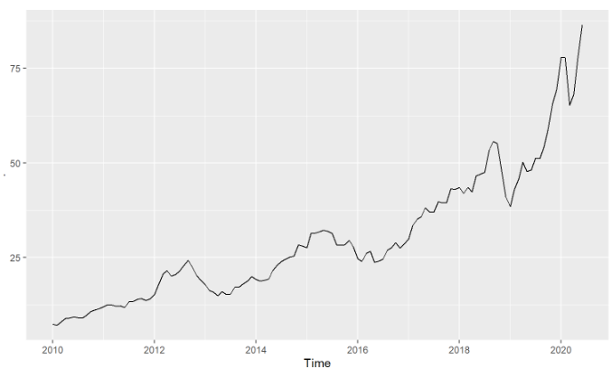

*The graph above show AAPL_train already splitted. As we can see the time (x-axis) has less observation than before.*

**STEP 7: CHECK AAPL_TRAIN TREND AND SEASONAL WITH DECOMPOSE**

***AAPL_dc <- decompose(AAPL_train, type = "multiplicative")***

***AAPL_dc %>% autoplot()***

*> AAPL_train, This data has an increasing trend from time to time. And also has seasonal. So, we use Hold Winters method.*

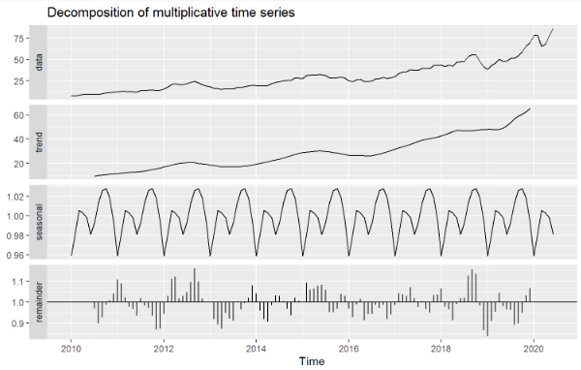

|  |  |
| --- | --- |
| AIM & DATASET DESCRIPTION | /25 |
| ALGORITHM | /20 |
| PROCEDURE | /45 |
| VIVA | /10 |
| TOTAL | /100 |

**RESULT:**

Thus the apply analytics for forecasting and inventory planning for a large retailer is implemented successfully in R studio.

|  |  |
| --- | --- |
| **Ex.No:6** | **PERFORM PREDICTIVE ANALYTICS FOR CUSTOMERS' BEHAVIOUR INMARKETING AND SALES** |
|  |

**AIM:**

To perform predictive analytics for customers' behaviour in marketing and sales

**ALGORITHM:**

Step 1: Import the data into R Studio and clean it to remove any outliers or missing values.

Step 2: Transform the data into a format suitable for predictive modeling.

Step 3: Exploratory Data Analysis: Identify correlations between different variables.

Step 4: Feature Selection: Select the most relevant variables to include in the predictive model.

Step 5: Predictive Modelling: Build a predictive model using algorithms such as logistic regression, decision trees, or random forests.

Step 6: Evaluate the model's performance on the test data.

**PROCEDURE:**

**STEP 1: IMPORT THE DATA INTO R STUDIO AND CLEAN IT TO REMOVE ANY OUTLIERS OR MISSING VALUES.**

library(caret)

customer_data <- read.csv("customer_data.csv")

customer_data_clean <- na.omit(customer_data)

**STEP 2: TRANSFORM THE DATA INTO A FORMAT SUITABLE FOR PREDICTIVE MODELING.**

set.seed(1234)

train_index <- createDataPartition(y = customer_data_clean$Bought_Product,

p = 0.7, list = FALSE)

train_data <- customer_data_clean[train_index,]

test_data <- customer_data_clean[-train_index,]

**STEP 3: EXPLORATORY DATA ANALYSIS: IDENTIFY CORRELATIONS BETWEEN DIFFERENT VARIABLES.**

summary(train_data)

ggplot(train_data, aes(x = Age, y = Income, color = Bought_Product)) +

geom_point()

**STEP 4: FEATURE SELECTION: SELECT THE MOST RELEVANT VARIABLES TO INCLUDE IN THE PREDICTIVE MODEL.**

**cor_matrix <- cor(train_data[,c("Age", "Gender", "Income", "Education", "Bought_Product")])**

**corrplot(cor_matrix)**

# Remove variables that are highly correlated or not relevant

**train_data_selected <- train_data[,c("Age", "Gender", "Income", "Bought_Product")]**

**test_data_selected <- test_data[,c("Age", "Gender", "Income", "Bought_Product")]**

**STEP 5: PREDICTIVE MODELLING: BUILD A PREDICTIVE MODEL USING ALGORITHMS SUCH AS LOGISTIC REGRESSION, DECISION TREES, OR RANDOM FORESTS.**

**model <- train(Bought_Product ~ ., data = train_data_selected, method = "glm", family = "binomial")**

**predictions <- predict(model, test_data_selected[,1:3], type = "prob")**

**confusionMatrix(predictions, test_data_selected$Bought_Product)**

Step 6: Evaluate the model's performance on the test data.

**new_customer <- data.frame(Age = 30, Gender = "Male", Income = 50000)**

**predict(model, new_customer, type = "prob")**

|  |  |
| --- | --- |
| AIM & DATASET DESCRIPTION | /25 |
| ALGORITHM | /20 |
| PROCEDURE | /45 |
| VIVA | /10 |
| TOTAL | /100 |

**RESULT:** Thus the perform predictive analytics for customers' behaviour inmarketing and sales is implemented successfully in R studio.

|  |  |
| --- | --- |
| **Ex.No:7** | **TIME SERIES DECOMPOSITION OF DATA** |
|  |

**AIM:**

To read and decompose dataet with time series analysis

**ALGORITHM:**

Step 1: Reading in Data

Step 2: Plot the difference in the seasons

Step 3: Time Series Decomposition

**PROCEDURE:**

install.packages(“tidyverse”)

install.packages(“seasonal”)

install.packages(“fpp2”)

library(tidyverse)

library(seasonal)

library(fpp2)

**STEP 1: READING IN DATA**

**furniture <- read_csv("give file path with file name.csv") //example //D//store.csv**

**head(furniture)**

*realtime_start realtime_end date value*

*1 2018-12-11 2018-12-11 1992-01-01 3311*

*2 2018-12-11 2018-12-11 1992-02-01 3360*

*3 2018-12-11 2018-12-11 1992-03-01 3445*

*4 2018-12-11 2018-12-11 1992-04-01 3415*

*5 2018-12-11 2018-12-11 1992-05-01 3510*

*6 2018-12-11 2018-12-11 1992-06-01 3521*

This is monthly data and that it begins in 1992. Now turn the value column into a time series object with the function ts() and then we will print it out.

**> sales <- ts(furniture$value)**

> sales

*Time Series:*

*Start = 1*

*End = 321*

*Frequency = 1*

*[1] 3311 3360 3445 3415 3510 3521 3470 3461 3521 3576 3592 3579 3600 3636 3525 3672 3739 3721 3811*

*[20] 3815 3861 3837 3810 3761 3984 4037 4040 4100 4017 4066 4138 4179 4127 4185 4189 4223 4233 4153*

*[39] 4199 4274 4276 4340 4312 4397 4405 4404 4520 4476 4484 4557 4539 4569 4596 4626 4645 4573 4617*

*[58] 4732 4704 4766 4787 4807 4860 4856 4785 4890 4909 4952 4979 4915 4996 4818 4943 4959 5013 4946*

*[77] 5040 4958 4994 4981 5015 5073 5015 5073 5117 5144 5087 5185 5165 5165 5195 5150 5358 5344 5434*

*[96] 5350 5373 5284 5406 5220 5289 5293 5210 5236 5490 5191 5166 5317 4956 5020 5036 5130 5117 5144*

**> sales <- ts(furniture$value, frequency = 12, start = 1992)**

**> sales**

*Jan Feb Mar Apr May Jun Jul Aug Sep Oct Nov Dec*

*1992 3311 3360 3445 3415 3510 3521 3470 3461 3521 3576 3592 3579*

*1993 3600 3636 3525 3672 3739 3721 3811 3815 3861 3837 3810 3761*

*1994 3984 4037 4040 4100 4017 4066 4138 4179 4127 4185 4189 4223*

*1995 4233 4153 4199 4274 4276 4340 4312 4397 4405 4404 4520 4476*

*1996 4484 4557 4539 4569 4596 4626 4645 4573 4617 4732 4704 4766*

*1997 4787 4807 4860 4856 4785 4890 4909 4952 4979 4915 4996 4818*

*1998 4943 4959 5013 4946 5040 4958 4994 4981 5015 5073 5015 5073*

1. Basic Plots

* Time Plots, autoplot()
* Season Plots, ggseasonplot()

autoplot(sales, main = "Furniture and Home Furnishing Sales: 1992-2018")

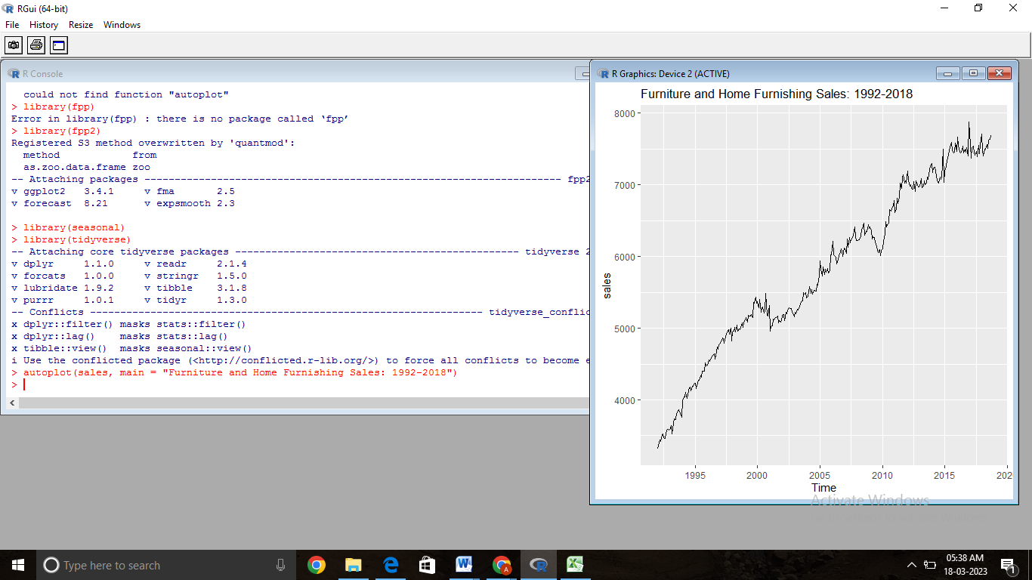

There is a general updward trend

The trend is not constant, it moves down during the recession

There is differences in sales based on month

**STEP 2: PLOT THE DIFFERENCE IN THE SEASONS**

To get a clearer understanding of the differences in the seasons (the months) lets make a seasonplot with ggseasonplot()

**ggseasonplot(sales, main = "Seasonal Plot: Furniture Sales")**

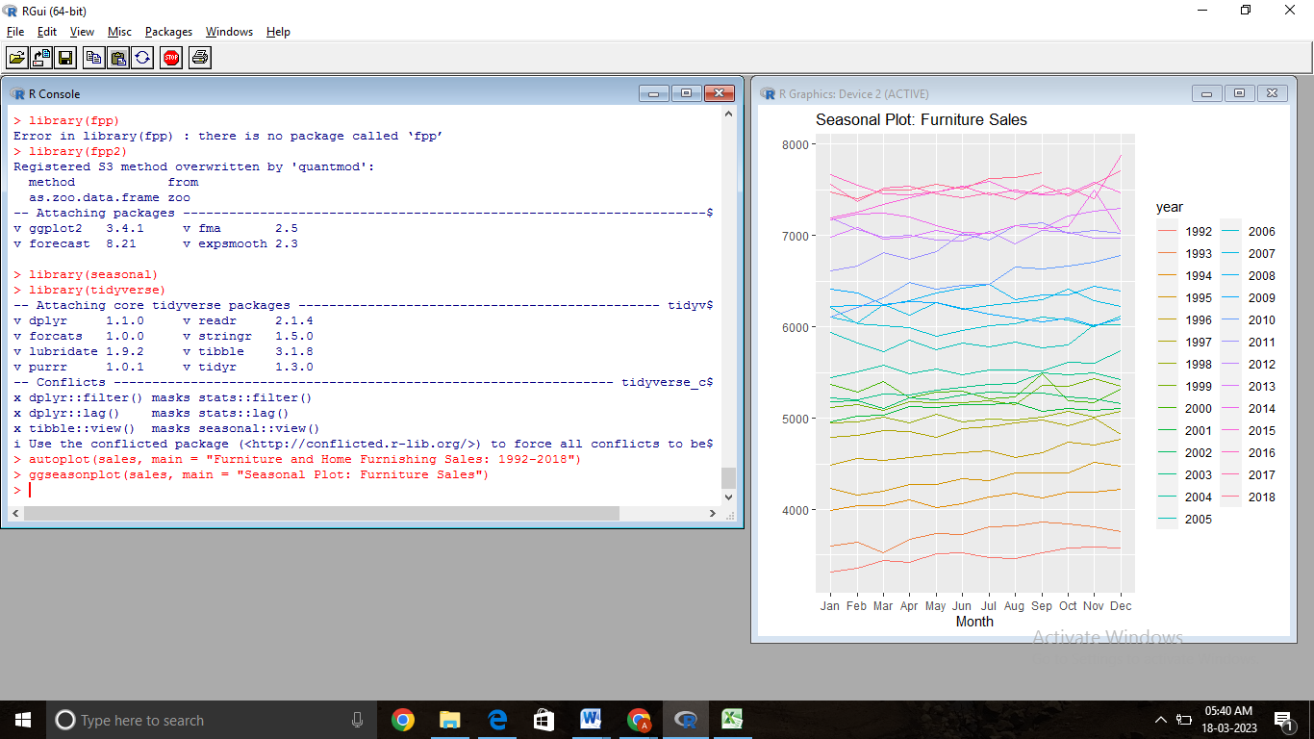

From this graph we can see that there is a jump at the end of each year, and that there is a small bump in March and August.

**STEP 3: TIME SERIES DECOMPOSITION**

decomposed_sales_multiplicative <- decompose(sales, type = "multiplicative")

autoplot(decomposed_sales_multiplicative)

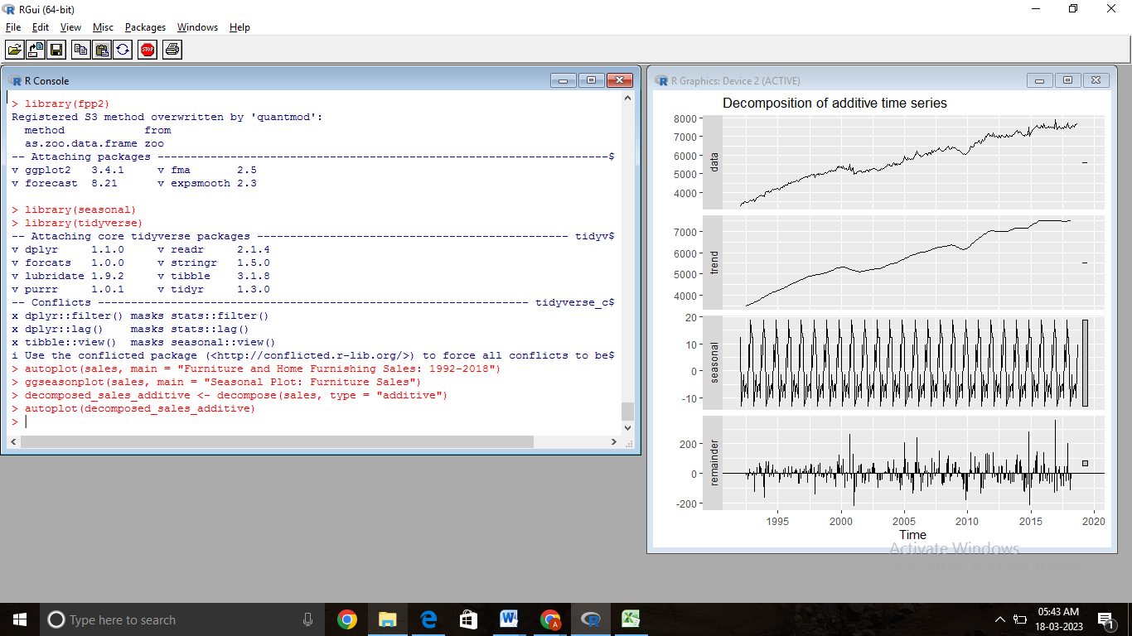Our original data (in panel 1, above) is now broken into 3 components.

a seasonal component (panel 2)

a trend component (panel 3)

a remained (panel 4)

Because our decomposition was additive, we can add the series in panels 2, 3, and 4 and get the top panel.

data = trend + seasonal + remainder

Here, remainder values of 0 are ideal, because that means the data can be explained by the season and the trend alone.

Remember that there are 12 seasonal values, one for each month that we add (or subtract) to the trend. These 12 seasonal values do not change over time and were found by averaging the seasonal affect of each month across all years.

**> install.packages("pacman")**

**> library(pacman)**

**> pacman::p_load(pacman, tidyverse, openxlsx, forecast, psych)**

**> str(furniture)**

**> describe(furniture)**

**> ggplot(furniture, aes(x=date, y=value)) + geom_point() + geom_smooth(method = 'lm')**

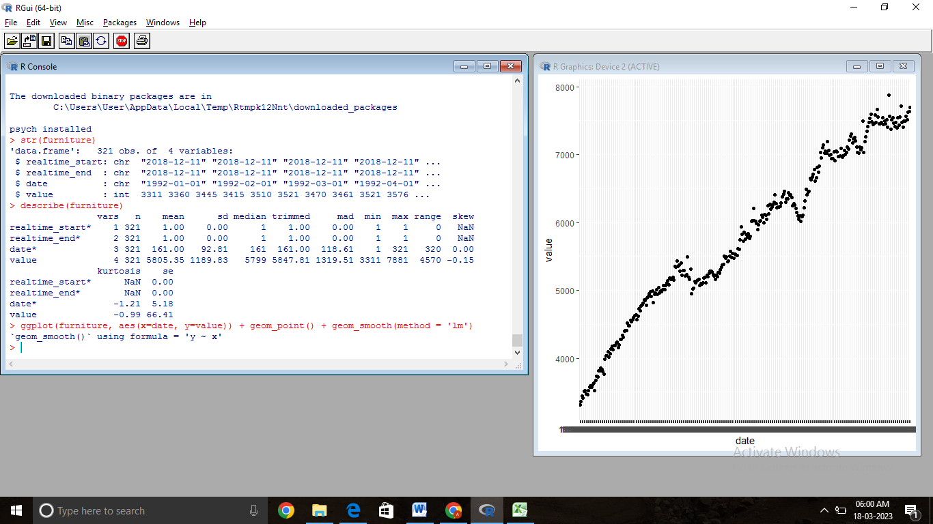

**> furniture_ts <- ts(data = furniture[,c(2,3)])**

**> furniture_ts**

*Time Series:*

*Start = 1*

*End = 321*

*Frequency = 1*

*realtime_end date*

*1 1 1*

*2 1 2*

*3 1 3*

*4 1 4*

*5 1 5*

*6 1 6*

*7 1 7*

> autoplot(furniture_ts, facets = TRUE)

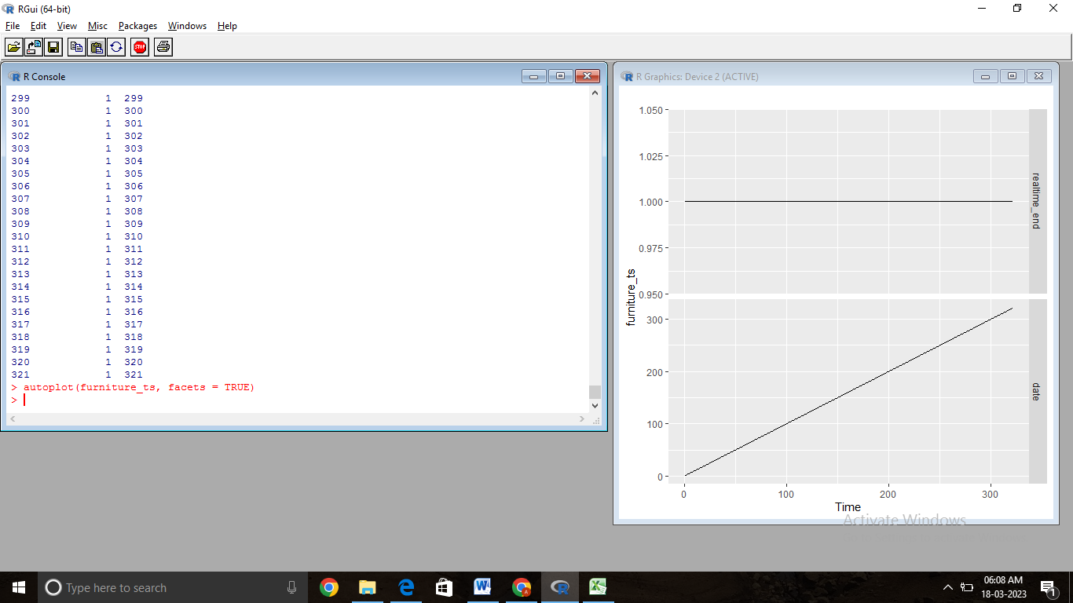

**> fit <- auto.arima(furniture_ts[, "realtime_end"], xreg = furniture_ts[, "date"], stationary = TRUE)**

**> fit**

Series: furniture_ts[, "realtime_end"]

ARIMA(0,0,0) with non-zero mean

Coefficients:

intercept

1

sigma^2 = 0: log likelihood = Inf

AIC=-Inf AICc=-Inf BIC=-Inf

> sales_increase <- coefficients(fit)[3]

> checkresiduals(fit)

Ljung-Box test

data: Residuals from ARIMA(0,0,0) with non-zero mean

Q* = NaN, df = 10, p-value = NA

Model df: 0. Total lags used: 10

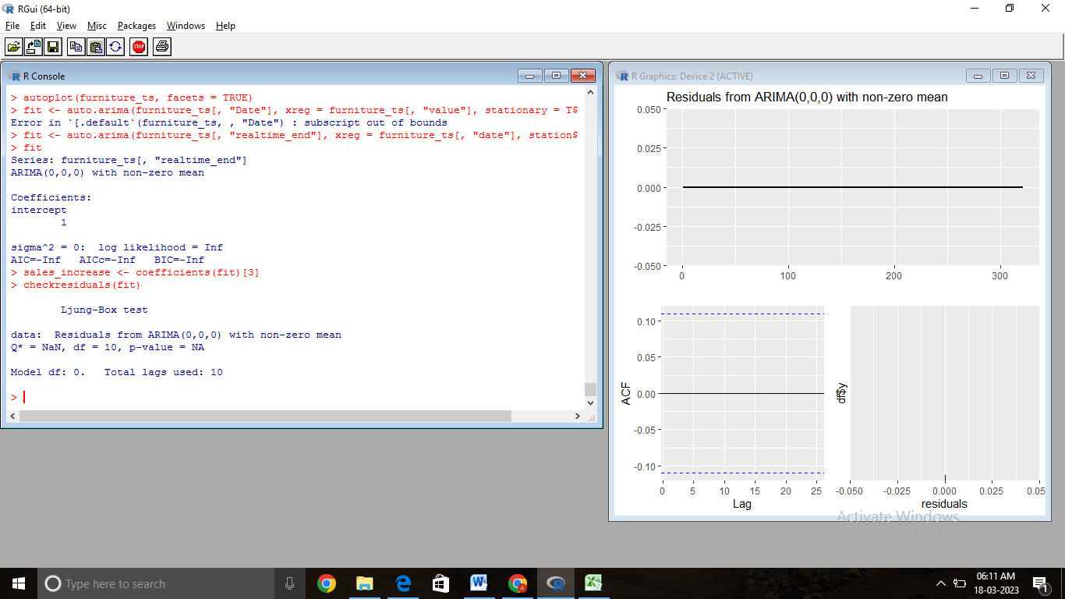

|  |  |
| --- | --- |
| AIM & DATASET DESCRIPTION | /25 |
| ALGORITHM | /20 |
| PROCEDURE | /45 |
| VIVA | /10 |
| TOTAL | /100 |

**RESULT:**

Thus the time series decomposition of data is implemented successfully in R studio.